Chapter 19, Problem 49.

Using impedances in the s domain, obtain the transmission parameters for the circuit in Fig.19.103.

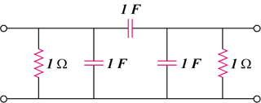

Figure 19.103
For Prob. 19.49.

